# **How to install wordpress in wamp**

## **Install Wordpress in your Wamp**

1. Download the latest wordpress form below link

<https://wordpress.org/download/>

You can download specific version of wordpress from below URL

<https://wordpress.org/download/releases/>

1. Once it will download Unzip it
2. Create a folder with your project name in WAMP folder

\\server1\source\my-wordpress-project

Note :: Folder name always in small with no space use dash (-) between two words

1. Copy wordpress files in your project folder

\\server1\source\my-wordpress-project

You only need to copy wordpress file not wordpress folder after you unzip

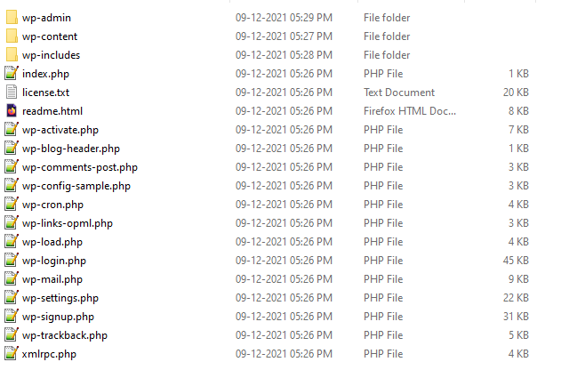

Only Copy above files

1. After Copy run your project on browser

## **B. Setup your wordpress project**

After follow the above steps when you run on browser it will ask you to setup the wordpress details

1. Welcome Page

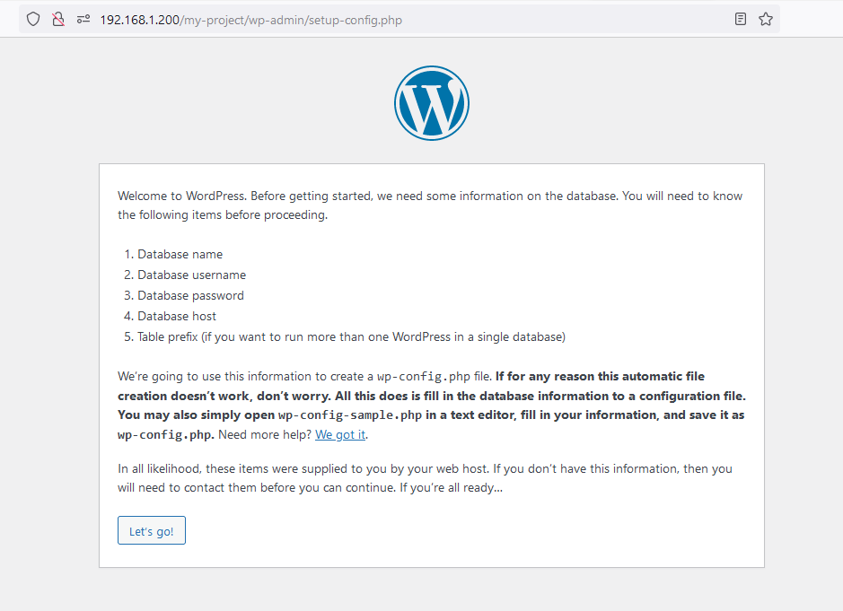

Click on **Let’s Go** button

1. Fill the Detail

Create database follow **Create Database point at the bottom of the document**

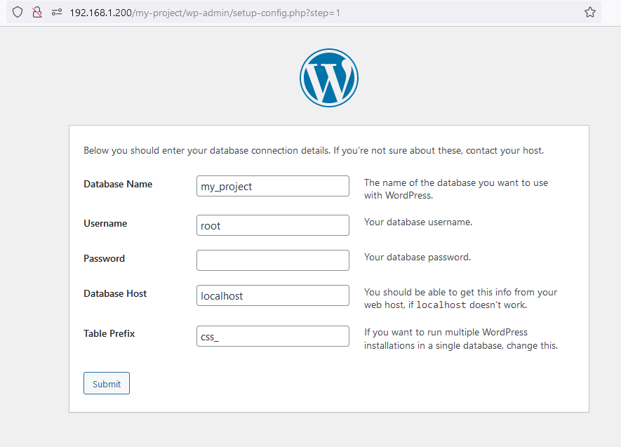

1. Create a wp-config.php

It will ask you to create config file with given code

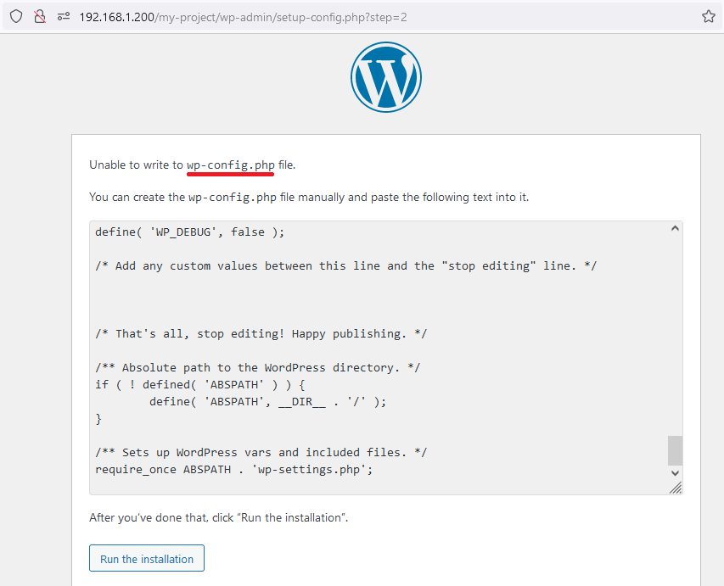

1. Where you create the config file

* Create file your project root folder
* \\server1\source\my-project
* File name has to >> wp-config.php
* Copy and past all the code which

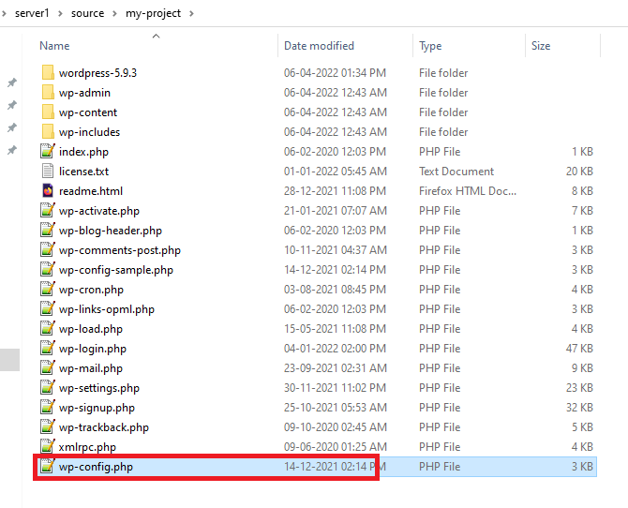

After you’ve done that, click “Run the installation”.

## **C. How to Create the Database**

1. Go to phpmyadmin >> <http://192.168.1.200/phpmyadmin>
2. Go to DatabasesTab

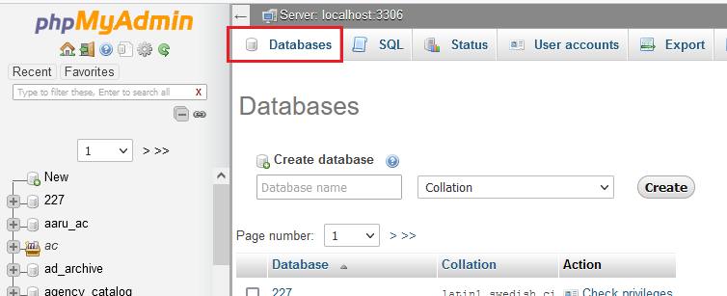

1. Enter Database name

Note: Database Name always in capital, no space use underscore (_) between two words

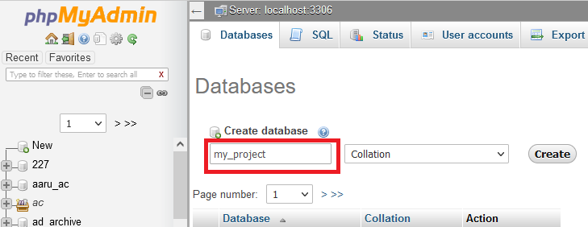

1. After entering name click on Create button

It will create database